**8-08-24 Java Lab Codes**

Program 1:

public class Main{

    int x=5;

    public static void main(String[] args)

    {

        Main myObj=new Main();

        System.out.println(myObj.x);

    }

}

Output:

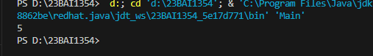

Program 2:

public class Main{

    int x=5;

    public static void main(String[] args)

    {

        Main myObj1=new Main();

        Main myObj2=new Main();

        System.out.println(myObj1.x);

        System.out.println(myObj2.x);

    }

}

Output:

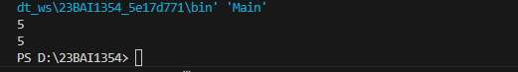

Program 3:

//Main.java

public class Main

{

    int x=5;

}

//Second.java

public class Second

{

    public static void main(String[] args)

    {

        Main myObj=new Main();

        System.out.println(myObj.x);

    }

}

Output:

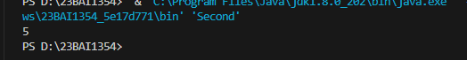

Program 4:

public class Main

{

    int x;

    public static void main(String[] args)

    {

        Main myObj=new Main();

        myObj.x=40;

        System.out.println(myObj.x);

    }

}

Output:



Program 5:

public class Main

{

    int x=10;

    public static void main(String[] args)

    {

        Main myObj=new Main();

        myObj.x=25; //x is now 25

        System.out.println(myObj.x);

    }

}

Output:

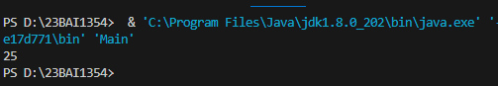

Program 6:

public class Main

{

    final int x=10;

    public static void main(String[] args)

    {

        Main myObj=new Main();

        myObj.x=25; //throws an error

        System.out.println(myObj.x);

    }

}

Output:

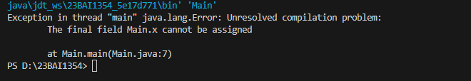

Program 7:

public class Main

{

    int x=10;

    public static void main(String[] args)

    {

        Main myObj1=new Main();

        Main myObj2=new Main();

        myObj2.x=25;

        System.out.println(myObj1.x);

        System.out.println(myObj2.x);

    }

}

Output:

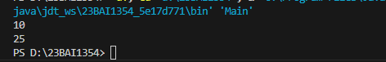

Program 8:

public class Main

{

    String fname="John";

    String lname="Doe";

    int age=24;

    public static void main(String[] args)

    {

        Main myObj=new Main();

        System.out.println("Name: "+myObj.fname+" "+myObj.lname);

        System.out.println("Age: "+myObj.age);

    }

}

Output:

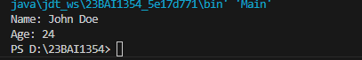

Program 9:

public class Main

{

    static void myMethod()

    {

        System.out.println("Hello World!");

    }

    public static void main(String[] args) {

        myMethod();

    }

}

Output:

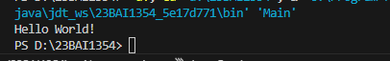

Program 10:

public class Main

{

    static void mStaticyMethod()

    {

        System.out.println("Static methods can be called without creating objects");

    }

    public void myPublicMethod() {

        System.out.println("Public methods must be called by creating objects");

    }

    public static void main(String[] args) {

        mStaticyMethod();

        Main myObj = new Main();

        myObj.myPublicMethod();

    }

}

Output:

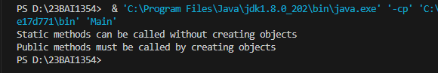

Program 11:

public class Main

{

    public void fullThrottle()

    {

        System.out.println("The car is going as fast as it can!");

    }

    public void speed(int maxSpeed)

    {

        System.out.println("Max speed is: "+maxSpeed);

    }

    public static void main(String[] args) {

        Main myCar = new Main();

        myCar.fullThrottle();

        myCar.speed(200);

    }

}

Output:

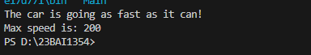

Program 12:

public class Main

{

    int x;

    //constructor

    public Main()

    {

        x=5;

    }

    public static void main(String[] args)

    {

        Main myObj = new Main();

        System.out.println(myObj.x);

    }

}

Output:

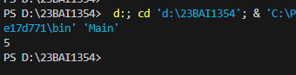

Program 13:

public class Main

{

    int x;

    //constructor

    public Main(int y)

    {

        x=y;

    }

    public static void main(String[] args)

    {

        Main myObj = new Main(5);

        System.out.println(myObj.x);

    }

}

Output:

